**1. Check if a String is a Palindrome**

Write a function to determine if a given string is a palindrome. A palindrome is a string that reads the same forward and backward (ignoring spaces, punctuation, and case).

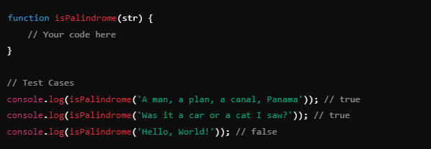

**2. Reverse a String**

Write a function to reverse a given string.

**3. Find the Longest Palindromic Substring**

Write a function to find the longest palindromic substring in a given string.

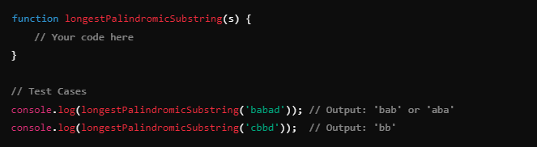

**4. Check if Two Strings are Anagrams**

Write a function to check if two given strings are anagrams of each other. Two strings are anagrams if they contain the same characters in the same frequency but in different orders.

**5. Remove Duplicates from a String**

Write a function to remove duplicate characters from a string while preserving the order of the first appearance of each character.

**6. Count Palindromes in a String**

Write a function to count how many distinct palindromes are in a given string. A palindrome is considered distinct based on its start and end position in the string.

**7. Longest Common Prefix**

Write a function to find the longest common prefix string amongst an array of strings. If there is no common prefix, return an empty string.

**8. Case Insensitive Palindrome**

Modify the palindrome function to be case insensitive, meaning it should ignore upper and lower case differences when checking for a palindrome.

